Final Retake Solution Spring 2021
1. Consider sending a packet from a source host to a destination host over a fixed route. List the delay components in the end-to-end delay. Which of these delays are constant and which are variable? (10 points)

The delay components are processing delays, transmission delays, propagation delays, and queuing delays. All of these delays are fixed, except for the queuing delays, which are variable.

2. How long does it take for a packet of length 1,000 bytes to propagate over a link of distance 2,500 km, propagation speed 2.5 · 108 m/s, and transmission rate 2 Mbps? More generally, how long does it take a packet of length L to propagate over a link of distance d, propagation speed s, and transmission rate R bps? Does this delay depend on packet length? Does this delay depend on transmission rate? (10 points)

t_{prop} = d/s = 2500x10³/(2.5x10⁸) = 10.00 msec; no; no
3. Consider an HTTP client that wants to retrieve a Web document at a given URL. The IP address of the HTTP server is initially unknown. What transport and application-layer protocols besides HTTP are needed in this scenario? (10 points)

Answer 1
1. The IP address of the destination hosts and the port numbers of the destination socket.
2. You probably use a browser and a mail reader on a daily basis. You may also use an FTP user agent, a Telnet user agent, an audio/video player user agent (such as a Real Networks player), an instant messaging agent, a P2P file-sharing agent, etc.
3. In persistent HTTP without pipelining, the browser first waits to receive a HTTP response from the server before issuing a new HTTP request. In persistent HTTP with pipelining, the browser issues requests as soon as it has a need to do so, without waiting for response messages from the server.
4. A host’s authoritative name server provides the “official” translation of a hostname to an IP address (among other things). A host’s local name server is a proxy to the DNS system: the host first queries its local name server for a mapping; the local name server then obtains the mapping on the behalf of the querying host.

5. Web caching can bring the desired content “closer” to the user, perhaps to the same LAN to which the user’s host is connected. Web caching can reduce the delay for all objects, even objects that are not cached, since caching reduces the traffic on links.

Answer 2
Before the HTTP GET request can be sent for the web document, the HTTP client needs to obtain the IP address of the HTTP server hosting the document. So a DNS request is sent out to obtain the hostname to IP address mapping. Recall that DNS runs over UDP. Once the mapping is obtained, the HTTP client first establishes a TCP connection with the server (Recall that HTTP runs over TCP). Following the TCP connection establishment a GET request for the web document is sent over this connection. In summary, the following are the protocols that are used:
Application layer protocols: DNS and HTTP
Transport layer protocols: UDP for DNS; TCP for HTTP
4. Discuss the following. (10 points)
- List the four broad classes of services that a transport protocol can provide. For each of the service classes, indicate if either UDP or TCP (or both) provides such a service.

a) Reliable data transfer
TCP provides a reliable byte-stream between client and server but UDP does not.
b) A guarantee that a certain value for throughput will be maintained
Neither
c) A guarantee that data will be delivered within a specified amount of time
Neither
d) Security
Neither

- Why do HTTP, FTP, SMTP, and POP3 run on top of TCP rather than on UDP?

The applications associated with those protocols require that all application data be received in the correct order and without gaps. TCP provides this service whereas UDP does not.

- What is meant by a handshaking protocol?
A protocol uses handshaking if the two communicating entities first exchange control packets before sending data to each other. SMTP uses handshaking at the application layer whereas HTTP does not.

Transport Layer

5. Consider sending a large file from a host to another over a TCP connection that has no loss. (10 points)

- Suppose TCP uses AIMD for its congestion control without slow start. Assuming cwnd increases by 1 MSS every time a batch of ACKs is received and assuming approximately constant round-trip times, how long does it take for cwnd increase from 6 MSS to 12 MSS (assuming no loss events)?
It takes 1 RTT to increase CongWin to 6 MSS; 2 RTTs to increase to 7 MSS; 3 RTTs to increase to 8 MSS; 4 RTTs to increase to 9 MSS; 5 RTTs to increase to 10 MSS; and 6 RTTs to increase to 11 MSS
- What is the average throughout (in terms of MSS and RTT) for this connection up through time = 6 RTT?
In the first RTT 5 MSS was sent; in the second RTT 6 MSS was sent; in the third RTT 7 MSS was sent; in the forth RTT 8 MSS was sent; in the fifth RTT, 9 MSS was sent; and in the sixth RTT, 10 MSS was sent. Thus, up to time 6 RTT, 5+6+7+8+9+10 = 45 MSS were sent (and acknowledged). Thus, we can say that the average throughput up to time 6 RTT was (45 MSS)/(6 RTT) = 7.5 MSS/RTT.

6. Describe why an application developer might choose to run an application over UDP rather than TCP. (10 points)

An application developer may not want its application to use TCP’s congestion control, which can throttle the application’s sending rate at times of congestion. Often, designers of IP telephony and IP videoconference applications choose to run their applications over UDP because they want to avoid TCP’s congestion control. Also, some applications do not need the reliable data transfer provided by TCP.
7. Recall reliable data transfer over a lossy channel with bit errors: rdt 3.0. In case of packet losses the protocol uses a time based retransmission mechanism which requires a countdown timer which interrupts the sender after a given timeout. Hence in such a protocol the sender will need be able to a) start the timer each time a packet (either a first-time packet or a retransmission) is sent b) respond to a timer interrupt (taking appropriate actions) c) stop the timer. Given the FSM (Finite State Machine) of a sender in the figure below please provide the FSM (Finite State Machine) of the receiver. (10 points)

Reciever side of rdt 2.2 is also Reciever side of rdt 3.0

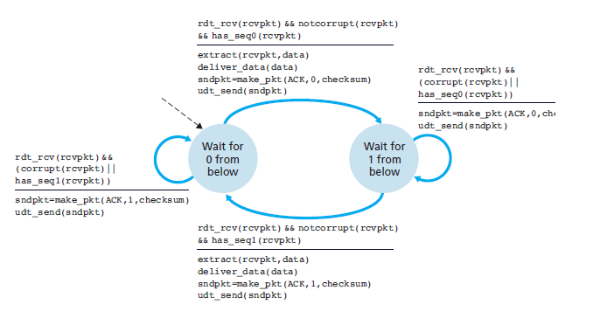

Routing Layer

8. Briefly discuss the following. (10 points)

- What is the difference between routing and forwarding?
Routing means finding a suitable path for a packet from sender to destination and Forwarding is the process of sending the packet toward the destination based on routing information

- Discuss why each input port in a high-speed router stores a shadow copy of the forwarding table.

With the shadow copy, the forwarding decision is made locally, at each input port, without invoking the centralized routing processor. Such decentralized forwarding avoids creating a forwarding processing bottleneck at a single point within the router.

- What is HOL blocking? Does it occur in input ports or output ports?
HOL blocking – a queued packet in an input queue must wait for transfer through the fabric because it is blocked by another packet at the head of the line. It occurs at the input port.

- Why are different inter-AS and intra-AS protocols used in the Internet?
We use different inter-AS and intra-AS routing protocols to solve the scalability and administrative authority problems. The scalability problem means, if we have all our routers in the Internet running on a single routing protocol, as the number of routers become large, the overhead involved in computing, storing, and communicating routing information will become unacceptable. The administrative authority problem means each ISP or organization may want to run its routers whatever routing protocols it please or hide aspects of its network’s internal organization from the outside.

9. Consider the following network. With the indicated link costs, use Dijkstra’s shortest-path algorithm to compute the shortest path from x to all network nodes. State of Initial routing table is shown below. (20 points)

